Group Members: Arav Raval, Erin Lin

ORF 387: FINAL PROJECT PROGRESS REPORT
PREDICTING EMERGING MUSIC ARTISTS USING NETWORK PROPERTIES

Codebase: https://github.com/arav-raval/Emerging_Artist_Prediction_ORF387/

PROJECT OVERVIEW
In the increasingly competitive music industry, recommendation and relations play a significant role in shaping listener preferences, discovering new artists, and propelling rising musicians into mainstream media. For example, recent successful artists like Sabrina Carpenter and Gracie Abrams experienced sharp increases in listeners on streaming platforms like Spotify due to frequent inclusion in app-generated playlists, association with existing prominent artists (through mediums like song collaborations), and dominance in recommendation systems. For example, despite comparable music styles and release timelines, Gracie Abrams rose to prominence more rapidly than similar artists such as Lizzie McAlpine, and potential explanations include an early feature from superstars like Taylor Swift early in the former’s career. Yet, quantitative coverage of such connections and recommendation algorithms within streaming platforms remains a mystery. In particular, we believe that much of the conversation lies in how music platforms dissect user behavior, artists similarities, and network properties to recommend new music.

This project will investigate how recommendation systems and underlying network properties influence the trajectory of emerging artists. Using publicly available information, we will analyze the key contributing factors to an artist’s visibility. Through this analysis, we aim to discover insights into the hidden mechanics behind surges in artist popularity and the mechanics of music recommendation.

OBJECTIVES
- Network Construction: Build a network where nodes represent artists and edges represent key relationships such as co-listening patterns, playlist co-occurrences, and genre similarities. We will also need to apply a weighting system to measure the strength of certain relationships. For example, a rising pop artist would consider a feature from Taylor Swift significantly more influential than most other artists, so this strength in the relationship needs to be adequately reflected in the created network.
  - Starting with US Top 50 Playlist, we are extracting an initial set of popular artists. Using that set, we are expanding our artist list based on network features like song collaborations, playlist coherence, etc.
- Data Parsing: Extract artist data from the Top 50 - USA playlist using the Spotify API. We will need to retrieve artist metadata, including artist ID, popularity, genre, and follower count. We will then extract each artist’s complete discography to assess song releases and feature collaborations.
- Case Studies: Analyze comparable artists (grouped by common features like genre) and root the discussion relative to “genre leaders” (i.e. Taylor Swift, Drake) to understand strengths of association and popularity trajectories
- Network & Recommendation Analysis:
  - Compute centrality measures to evaluate the influence of artists within a recommendation network
  - Use local grouping / community algorithms to create clusters based on similar listening patterns, genre, popularity, etc
- Potential Additional Step:
  - Prediction Model: Input the network into a machine learning model to use network features as predictors for the next “emerging artist”

PROGRESS TO DATE
- Set up authorization for Spotify API usage
- Extracted initial artist set
  - Copied the Top 50 - USA playlist into personal playlist (*See Current Challenges section)
  - Extracted all of the unique artists from the playlist
  - Extracted all of the features of each artist (ID, popularity, followers, genre)
  - Extracted each artist’s full discography
- Created the initial graph of nodes
  - Weighted the nodes based off of relative number of followers
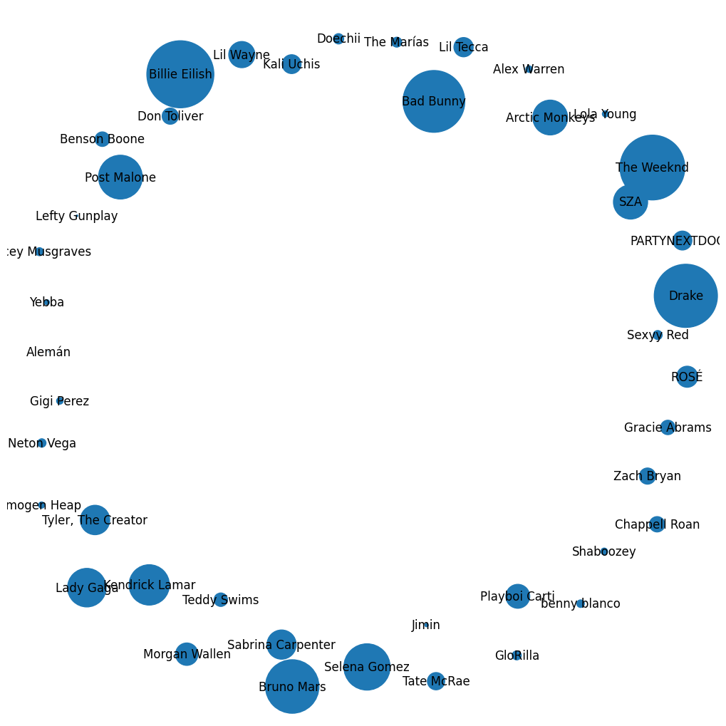
- Expanded Artist Set based on song collaborations
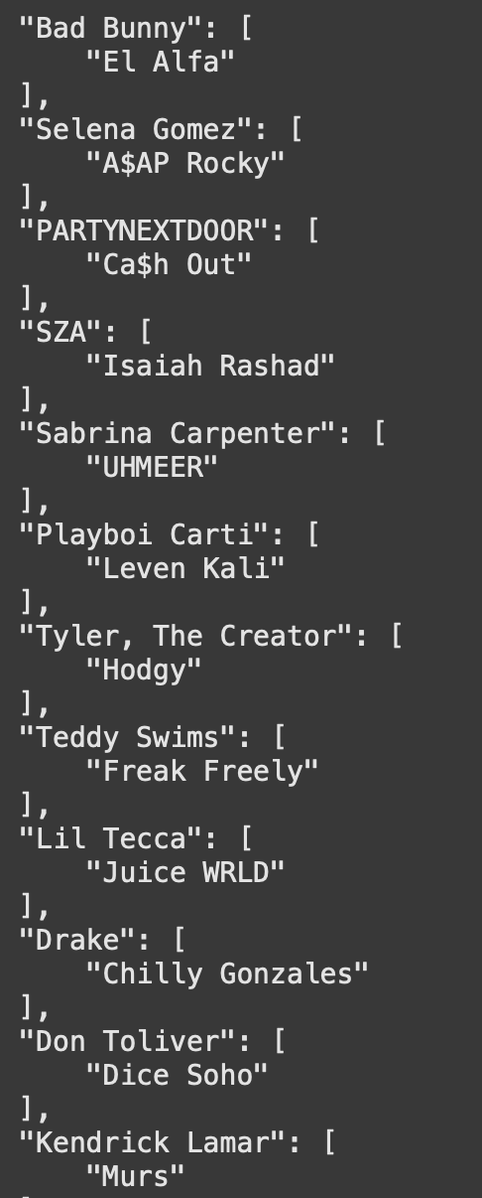
- [In Progress] Expanding the network to include new artists, and draw edges between artists that have collaborated

CURRENT CHALLENGES
We are currently using personal data such as personal listening history and our own created playlists because the Spotify API disallows using Spotify-featured playlists due to their guidelines on preventing AI model training. We also attempted webpage data scraping, but this was also not successful. Given the sheer volume of API calls this project requires and the imposed rate limits of 10,000 / requests per hour, we are also still only able to store a limited number of total artists in our graph. We are exploring the possibility of creating a database to avoid repetitive calls to the API and reconstruction of the graph every time the notebook runtime ends.

This would modify our research question to predicting the next emerging artist that we would listen to based on our listening preferences, but as we work though our project in the next month, we hope to work around this issue and continue to answer our original question: can we predict public emerging artists based on music recommendation and media network properties?

NEXT STEPS
- Create various layers / types of edges and determine weights for each connection between artist nodes.
- Calculate centrality metrics to assess influence and visibility within the network.
- Validate the model on known emerging artists.
- Conduct comparative analysis between artists who followed different growth trajectories (e.g., Gracie Abrams vs. Lizzie McAlpine) to validate findings.

QUESTIONS
- What additional features (e.g. artist collaboration frequency) should be considered in weighting network edges?
- How do we scale the features to introduce a variety of new edge types, and how do we decide the weight of each edge type (i.e. collaboration edge vs. co-occurrence on playlist edge)
- How do we address our current challenge of not being allowed to use the Spotify-featured playlists?

